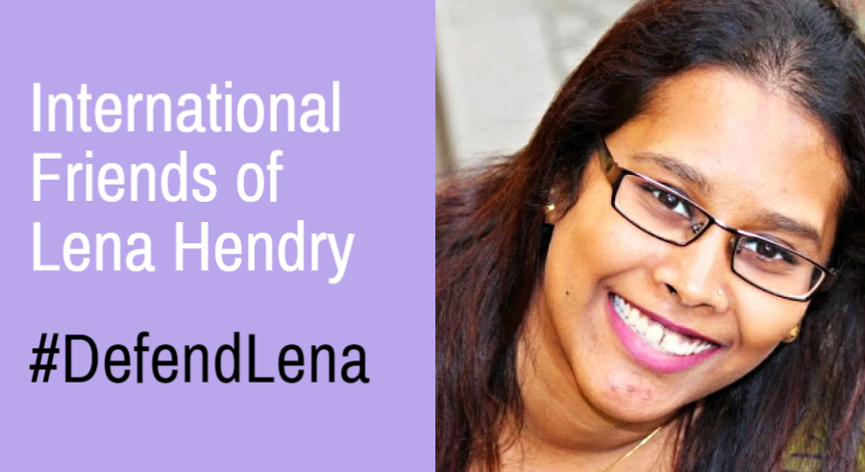

International Friends of Lena Hendry
C/O the Sri Lanka Campaign for Peace and Justice
Grayston Centre, 28 Charles Sq
London
N1 6HT

To [full addresses enclosed below]:

Mr. Mohamed Apandi Ali, Attorney General
Mr. Ahmad Zahid Hamidi, Minister of Home Affairs
Mr. Najib bin Tun Abdul Razak, Prime Minister of Malaysia

22nd February 2017

Urgent Appeal regarding Malaysian Human Rights Defender Lena Hendry

Your Excellencies,
On Tuesday 21st February 2017, Lena Hendry, a human rights defender in Malaysia, was convicted of showing the film No Fire Zone: The Killing Fields of Sri Lanka - an award-winning documentary film about human rights abuses at the end of Sri Lanka’s civil war - without the approval of Malaysia’s censorship authorities. She is due to be sentenced on the 22nd March this year.
I wish to protest in the strongest terms about this disgraceful conviction which flies in the face of every principle of free speech and democratic debate.
Lena faces a maximum sentence of three years in jail and/or a maximum fine of 30,000 Malaysian Ringgit (£5400/$6700) under Malaysia’s Film Censorship Act which criminalizes the possession, distribution, or showing of films which have not been approved by the country’s censorship board. It effectively makes any film – or even publicity about any film – illegal if it does not have prior approval from the censorship authorities.
The reality is that the law is being used for political censorship, and that is what appears to lie behind the conviction of Lena.
On the 3rd July 2013 the Malaysian human rights organization Pusat KOMAS showed No Fire Zone: The Killing Fields of Sri Lanka to an invited audience of 150 people in Kuala Lumpur, at a screening attended by the film’s director, Callum Macrae. The group went ahead with the screening despite pressure from the Sri Lankan government whose forces were accused in the film of responsibility for war crimes. As the screening got under way it was raided by 30 officials from the Malaysian Home Ministry, the Police and Immigration Officials. Three organizers were arrested and Lena was subsequently charged in September 2013. A three year-long legal battle ensued culminating in this guilty verdict.
The use of this draconian law to attack and prevent freedom of speech is disturbing and unacceptable, and is in danger of bringing Malaysia into international disrepute.
The Emmy and Bafta nominated film which Lena is charged with showing is now widely and internationally acknowledged to have played a key role in exposing the terrible atrocities committed at the end of the war in Sri Lanka. It also helped convince delegates to the UN Human Rights Council to launch a major inquiry into the events which saw tens of thousands of innocent Tamil civilians slaughtered in the space of a few weeks – most killed by government shelling.
The Sri Lankan government which ordered that shelling – and which tried to stop this screening – has now been replaced by popular vote of the Sri Lankan people. But many of its leading members and military officials stand accused of direct command responsibility for war crimes and crimes against humanity.
History has vindicated the film. Yet while the perpetrators of the crimes it exposed walk free, Lena faces jail for showing it. Her conviction is a denial of free speech which brings shame on Malaysia and should immediately be overturned.
Yours sincerely,
International Friends of Lena Hendry
Friends of Lena Hendry can be contacted through: NoFireZoneMovie@gmail.com
#DefendLena

Recipient addresses:
Mr. Mohamed Apandi Ali  Attorney General  Attorney General's Chambers  No 45, Persiaran Perdana Precint 4,  62100 Putrajaya, Malaysia  Twitter: @AGCPutrajaya | Mr. Ahmad Zahid Hamidi,  Minister of Home Affairs,  Ministry of Home Affairs,  Blok D1 & D2, Kompleks D,  Federal Government Administrative Centre,  62546 Putrajaya, Malaysia.  Twitter: @Zahid_Hamidi | Mr. Najib bin Tun Abdul Razak,  Prime Minister of Malaysia,  Prime Minister’s Office Malaysia,  Main Block, Perdana Putra Building,  Federal Government Administrative Centre,  62502 Putrajaya, Malaysia.  Twitter: @NajibRazak

