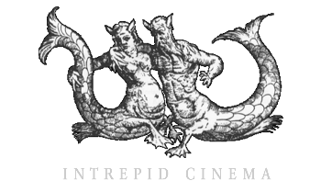
AWARD-WINNING FEATURE DOCUMENTARY ABOUT THE FAROE ISLANDS – THE ISLANDS AND THE WHALES TO BE RELEASED IN CINEMAS 29th MARCH
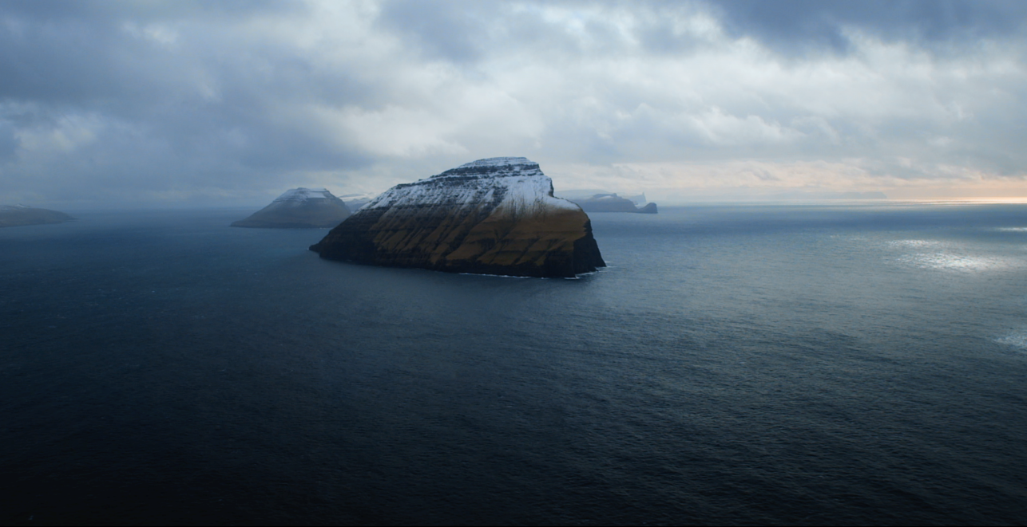
Intrepid Cinema, Cosmic Cat and Dartmouth Films are thrilled to announce the release of the critically acclaimed, award winning feature documentary THE ISLANDS AND THE WHALES in UK cinemas from 29th March. Its UK Film Premiere will take place on Thursday 29 March, 7pm at Picturehouse Central followed by a Q&A, chaired by Jon Snow, with and Director Mike Day and guest which will be streamed live to UK wide cinemas.

THE ISLANDS AND THE WHALES is directed and produced by Scottish director and cinematographer Mike Day (Aleppo’s Fall, The Guga Hunters of Ness) and co-produced by Henrik Underbjerg and Stefan Frost. Nominated for BAFTA Scotland’s Best Single Documentary and Best Documentary at the Edinburgh International Film Festival the film has gone on to win numerous awards including: Hotdocs Emerging International Filmmaker Award, DOC NYC Grand Jury Prize, Best Documentary Phoenix International Film Festival and the Princeton Environmental Film Festival.

The pilot whale hunters of the Faroe Islands believe that hunting is vital to their way of life, but when a local professor makes a grim discovery about the effects of marine pollution, and the seabirds populations collapse, environmental changes threaten to change the community and their way of life forever.
The Faroese are among the first to feel the effects of our ever more polluted oceans. They have discovered that their beloved whales are toxic, contaminated by the outside world. What once secured their survival now endangers their children and the Faroe Islanders must make a choice between health and tradition.

Director Mike Day said “This film took five years to make and I'm very excited to now bring this film to UK audiences on the big screen. The majestic landscapes and sounds of the Faroe Islands deserve the full cinema experience, and the story the islanders and the whales have to tell us is strikingly relevant and vital. I look forward to holding Q&As around the country and discussing the film.”
******
“An enveloping look at a community whose centuries-old way of life may be ending.” —John DeFore, Hollywood Reporter
“A film that is jaw-dropping in its visual splendour.” —Matthew Anderson, Cinevue

**************
More information:
Running Time: 80mins
Cert: 12A
Website www.theislandsandthewhales.com
Facebook: www.facebook.com/theislandsandthewhales
Twitter: https://twitter.com/IATWfilm
Trailer: www.vimeo.com/112625935

PRESS:
For further information, screenings, interviews and assets please contact:
ARPR – Alex Rowley
alex.rowley@ar-pr.co.uk

STILLS: http://bit.ly/2nHH5vN

NOTES TO EDITORS:

DIRECTOR’S BIOGRAPHY – MIKE DAY

Mike Day is a Scottish director and cinematographer. Formerly a lawyer, his debut 59minute documentary, The Guga Hunters of Ness, screened on the BBC in 2011 and at festivals internationally. Mike founded Intrepid Cinema in 2009 before heading out into the North Atlantic to document the last ten seabird hunters permitted to continue a traditional gannet hunt in the Scottish Outer Hebrides. This was the first time since 1959 that the hunters had allowed this once secretive tradition to be filmed. After two weeks at sea they returned home with a rare glimpse into this vanishing world.

His current work is in many ways a continuation of this previous film and has seen him spending four years filming the community and natural world of the Faroe Islands.

Mike was listed as one the ’10 Filmmakers to Watch in 2012’ by Filmmaker Magazine, he was one of EDN’s 12 for the Future 2012, the first Scot on the Nordic programme, he is a Sundance Documentary Film Program Fellow, and is supported by the Scottish Documentary Institute’s Docscene programme and is BAFTA Scotland nominated for Best Documentary 2016.

FULL CREDITS

Title The Islands and the Whales
Genre Feature Documentary
Production 2016
Country of Origin United Kingdom / Scotland
Language Spoken Faroese / English / Danish
Duration 81 minutes
Cameras Sony F3, Black Magic Pocket Camera, Nikon D800
Prores HQ 422 10 bit HD
Screen Ratio 16:9 container 1:1.94
Format DCP, ProResHQ, Blu-ray
Sound format Dolby Atmos, 7.1, 5.1
Director Mike Day
Production Company Intrepid Cinema
Producer Mike Day
Co-producer Henrik Underbjerg & Stefan Frost
Executive Producers Minette Nelson
David Eckles
George Day
Karen Day
John Atkinson
Phil Noran
Matt Day
Niall Christie
Rachel Wexler
Jez Lewis
Cinematographer Mike Day
Editors Mary Lampson
Nicole Hálová
Mike Day
Claire Ferguson
David Charap
Sound Designer Chris Barnett
Composer Antony Partos
Mike Sheridan

Partners and funders Sundance Documentary Institute
San Fransisco Film Society
The Filmmaker Fund
Wellcome Trust
Creative Scotland
The Scottish Documentary Institute
The Danish Documentary Institute
Influence Film Foundation
Creative Europe
GoodPitch
Factum Arte
DR

