Graph analysis lesson 1- CO₂ measurements at Baring Head and Mauna Loa
5 mins intro Rally chart:
In partners write quick-fire 1 or 2 words at a time about Climate Change. Three minutes total, get as many words as possible to beat neighbouring group.
Share ideas – hopefully CO₂ / greenhouse gases / temperature increase / fossil fuels will be common thread. Relate to current learning about compounds, prior learning on gases, combustion.

5 mins background:
Coming up in Social Studies you will look at Climate Change. This will match nicely with a number of or Science Capabilities – especially ‘Engaging with Science’.
Here’s a great example of how scientists ‘Gather and Interpret Data’ – measuring atmospheric CO₂ in NZ – just around the corner at Baring Head!

10 minutes Thin Ice video clip: Measuring CO₂ at Baring Head, Wellington, New Zealand

5 minutes intro to graph activity:
One Science Capabilities focus for this topic (Particles) is ‘Interpreting Representations’. Partly that has been about using conceptual model of particle nature of matter, partly about interpreting graphs.
Talk through graphs of CO₂ record from Baring Head: https://www.niwa.co.nz/atmosphere/our-data/trace-gas-plots/carbon-dioxide for CO₂ (and methane) data collected from Baring Head and Arrival Heights, Antarctica.

25 minutes graph interpretation activity 1:
Complete page one in groups of 3.
Extension questions for fast finishers:
- What processes do you know of that ‘use up’ CO₂?
- What processes do you know of that release CO₂?
- What percentage is 350ppm equal to?
- Compare and contrast atmospheric CO₂ and air (describe the similarities and differences).

5 minutes review of answers.
Determine difference between seasonal variation and average/overall CO₂ trend, including accelerating rate of increase.
Identify the seasonal variation and discuss possible reasons for such regular variation.

5 minutes review Rally chart:
Additional/follow-up CER activity:
Use Claim/Evidence/Reasoning template with graph of atmospheric CO₂ at Baring Head / Mauna Loa / Arrival Heights, Antarctica
How many of your words were covered in the activity/video?
2 minutes to add any new words to chart.
Graph analysis lesson 2 - CO₂ measurements around the world
5 mins intro:
Review seasonal pattern identified in Mauna Loa data. Identify calendar timing of Northern Hemisphere seasons and the relationship with the measured timing of CO₂ peaks/troughs.
Overview of possible reasons for variations in CO₂. Relate to processes that use up or release CO₂ (Examples identified with trial class included increased use of electricity, increased combustion of fuels, photosynthesis and growth of plants, release of CO₂ from melting ice).

25 mins graph interpretation activity 2:
Shuffle groups of three (spread out students from groups that had correct ideas during activity 1).
Complete questions on second activity with data from four locations. Encourage students to focus on questions 4 and 5 to draw out differences in range of CO₂ variation between Northern and Southern Hemisphere records and seasonal timings of peaks and troughs.

10 minutes review of answers:
Discuss increased photosynthesis during spring, reducing concentration of CO₂ in atmosphere and decreased photosynthesis during autumn. South Pole record has opposite phase due to opposite seasons (note that Samoa matches Northern Hemisphere seasons, but less variation).
Discuss Northern Hemisphere having greater variation due to greater total landmass and greater plant cover so greater effect of photosynthesis.
So why does South Pole show any variation at all, given the lack of land-based planet life in Antarctica and limited plant cover in lower Southern Hemisphere? (one student offered idea of phytoplankton).
NOTE: students probably have some prior knowledge of photosynthesis, but hopefully at least have idea of plants ‘using up’ carbon dioxide and producing oxygen.

6 minutes Thin Ice video clip: Voyage to the Southern Ocean - Part 6: Oceans and CO₂
http://thiniceclimate.org/blog/details/2020/voyage-to-the-southern-ocean-part-6-oceans-and-co2

4 minutes Thin Ice video clip: Voyage to the Southern Ocean - Part 7: Forests of the Ocean
http://thiniceclimate.org/blog/details/2021/voyage-to-the-southern-ocean-part-7-forests-of-the-ocean

5 minutes summary:
Write a summary paragraph identifying the key reasons why CO₂ shows seasonal variation and the different organisms responsible for this.
NOTE: Could use CER format for this.
Additional/follow-up CER activity:
Use Claim/Evidence/Reasoning template with graph of atmospheric CO₂ at differing locations.

Interpreting representations: CO₂ Graphs #1
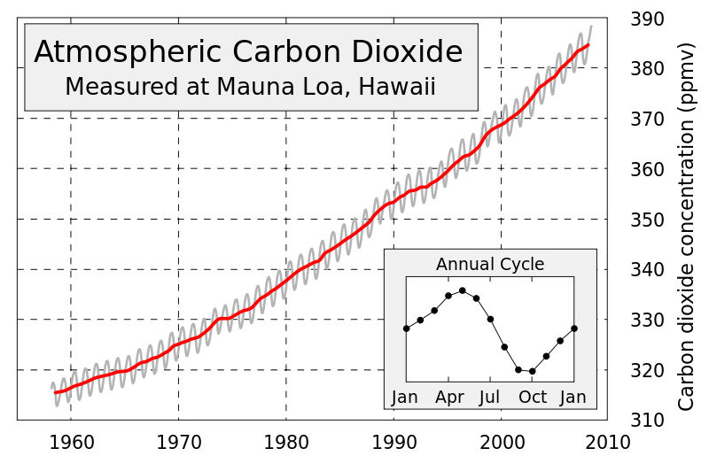
Graph sourced from: https://www.skepticalscience.com/warming-co2-rise.htm
Questions:
- Write a sentence that describes the general (overall) pattern shown for the measurements on the main graph.
  - ‘ppmv’ means ‘parts per million by volume’

On the main graph there are two lines; the grey line and the bold/red line.
- Make lists of differences and similarities that you identify between the lines.

- Why do you think there are two different lines?

Names: __________________________________________
The wavy line has peaks (high points) and troughs (low points).
- Label one peak and one trough on the graph.

- How many peaks are there between 1960 and 1970?

- How many troughs are there between 1980 and 1990?

There is a small graph inset titled ‘Annual Cycle’
- What does this inset graph show?

- Why is it included? (What does it show more clearly than the main graph?)

- What happens to CO₂ levels over this regular annual cycle?

- Why do you think this might happen?

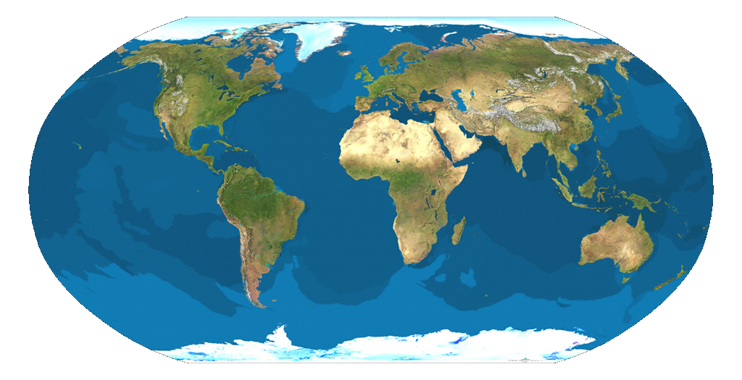
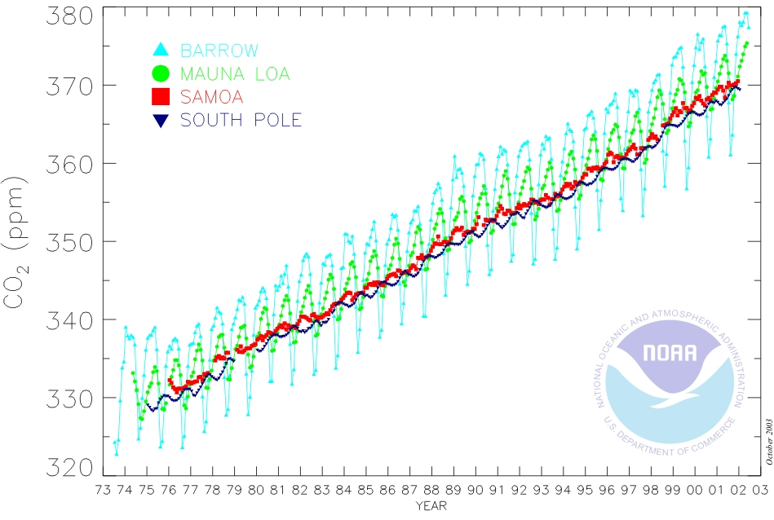
Interpreting representations: CO₂ Graphs #2

Questions:
Graph sourced from: http://www.co2.ulg.ac.be/objects/mangroves_co2_air.htm
- List the similarities between this graph and the first graph.

- List the differences between this graph and the first graph.

- What do the four different lines on the graph represent? Use the map to help your explanation.
Names: __________________________________________

Look closely at both the timing of the peaks and troughs and the range of the variation in CO₂ (the difference between the peaks and troughs) of the four lines.
- What similarities can you find between the different lines on this graph?

- What differences can you find between the different lines on this graph?

- Why might the patterns for the South Pole data be different compared to the others? (Think about any differences between the Northern and Southern Hemispheres)

